**Week 3**

**NAME:HASHIR KHAN**

**ID: TN/IN01/PY/007**

**DOMAIN:PYTHON**

**Step 1: Ask the user for inputs using input()**

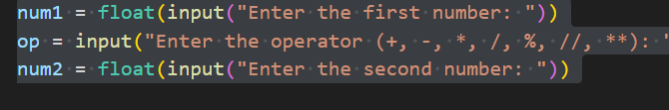

* **float() converts input text to number (decimal)**
* **op is a string like + or /**

**Step 2: Use if/elif to choose operation**

**We'll write a chain of if and elif to check which operator was entered.**

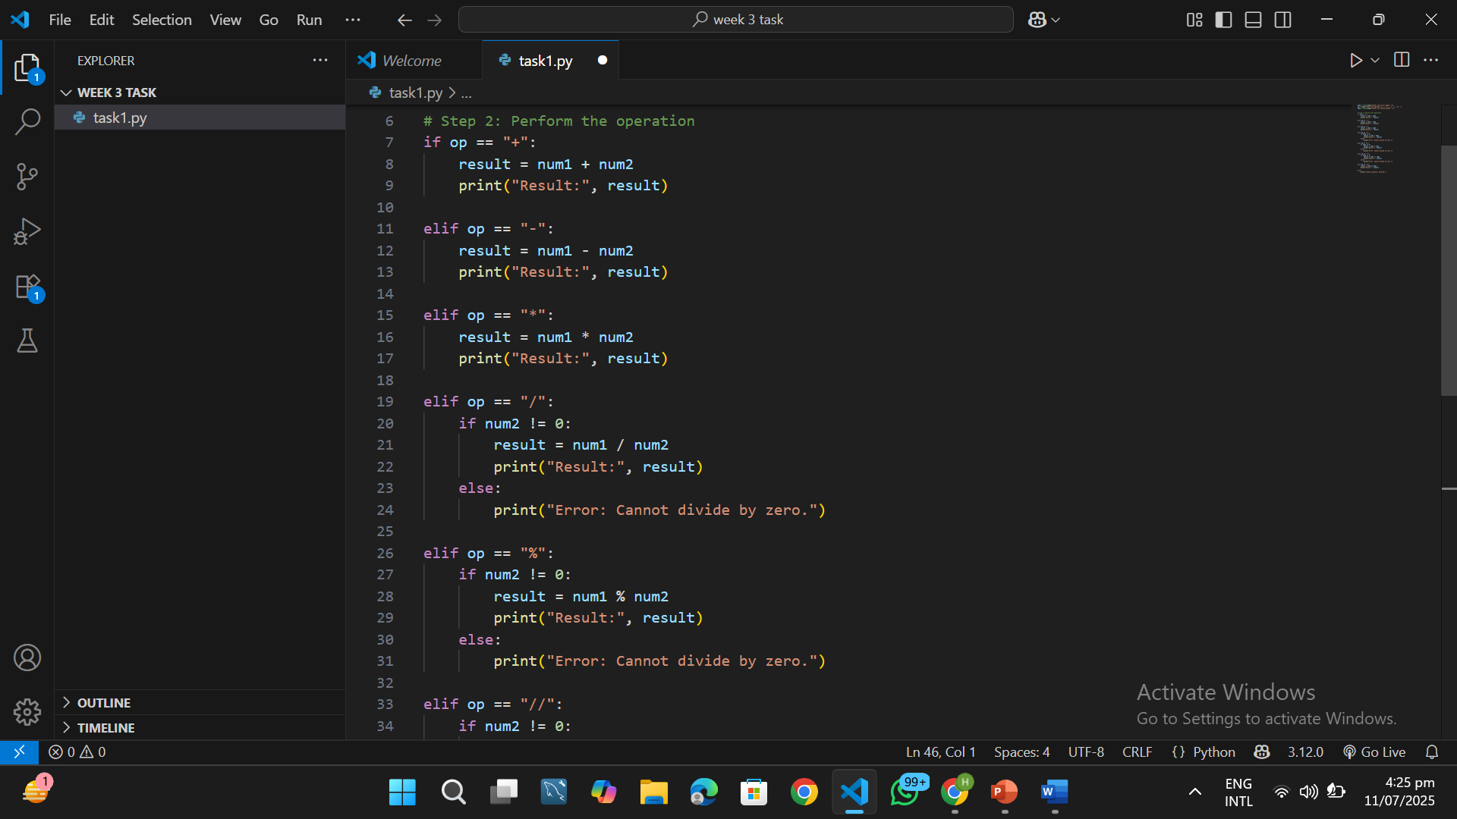

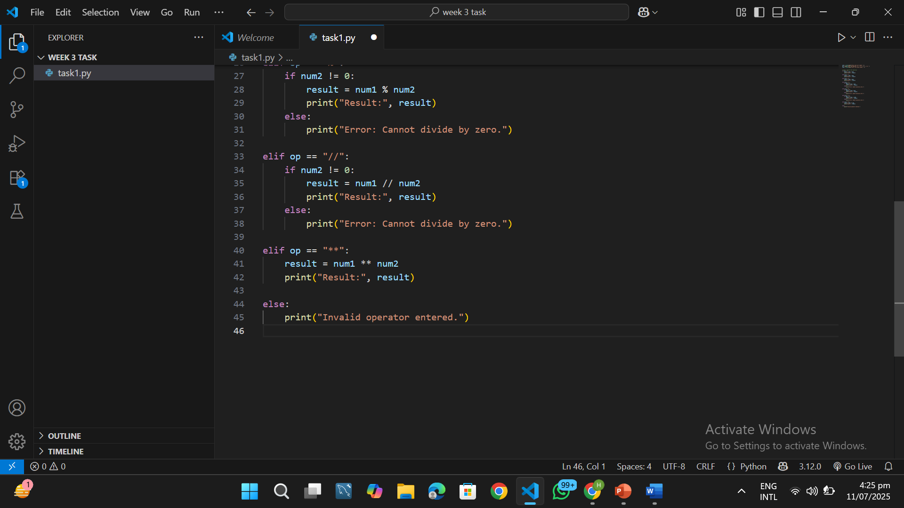

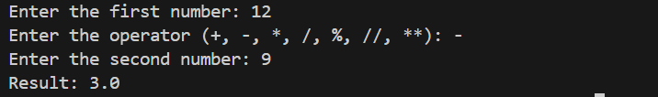

**Task 2**

**Step 1: Input**

**We use float(input(...)) to let the user enter marks for 3 subjects:**

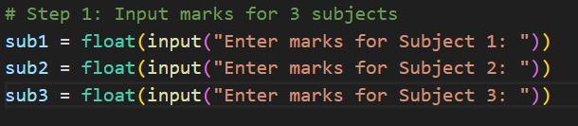

**Step 2: Total Marks**

**Add all 3 subject marks:**

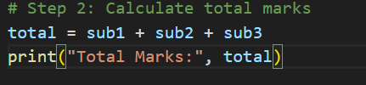

**# Step 3: Calculate percentage**

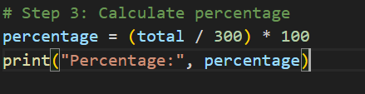

**Step 4: Grade Check (Using if, elif, else)**

**We compare percentage and assign grade:**

| **Percentage** | **Grade** |
| --- | --- |
| **85 or more** | **A** |
| **70 to 84.99** | **B** |
| **50 to 69.99** | **C** |
| **Below 50** | **Fail** |
|  |  |

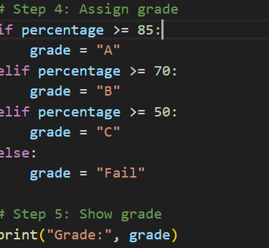

**Task 3**

**Step 1: Input Income**

**What’s Happening?**

* **input(...) → shows message and waits for the user to type something**
* **Example: user types 30000**
* **float(...) → converts that text into a number with decimal**
* **That number gets stored in a variable named income**

**🗃️ Think of income like a box that now contains 30000.0**

**Step 2: Input Expenses**

**What’s Happening?**

* **Same as before, now we ask for expenses.**
* **Example: user types 20000**
* **expenses now stores that value → like a second box**

**Now i have:**

* **income = 30000.0**
* **expenses = 20000.0**
* 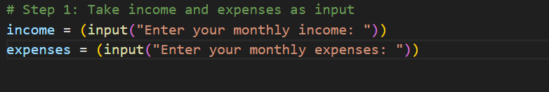
* **# Step 2: Calculate savings**

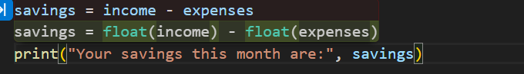

**# Step 3: Classify the savings**

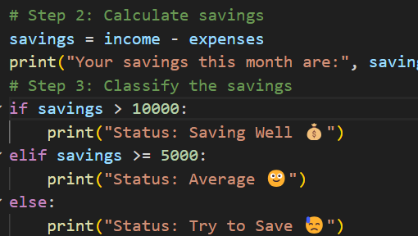

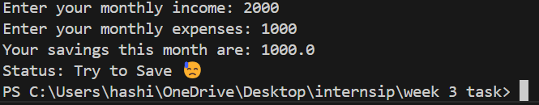

**Task 4:**

**Step 1: Ask for username**



**Step 2: Ask for password**



**Step 3: Check if both username and password are correct**



**`**

**If not work**



**Output**

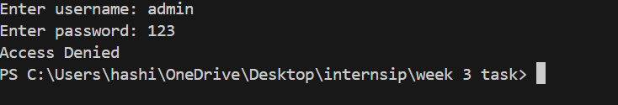

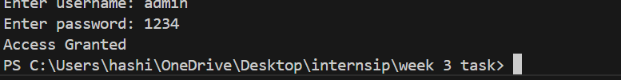

**Task 5**

**Step:1 Take input from user**



**Step:2**

**Apply condtion**

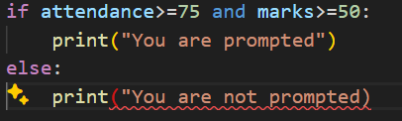

**Task 6**

**Step 1: Ask for number of products**



**Step 2: Ask for total price**



What’s Happening?

* input() takes input from user
* int(...) is used for whole numbers (like 2, 5, 10)
* float(...) is used for decimal numbers (like 1525.50)

📦 Example:

* Products = 4
* Price = 1200.00

**Step 3: Apply Discount condition**

